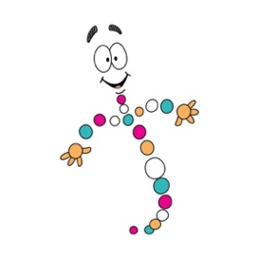
Biology
Speak, Write, Interpret

Name:___________________________________________________________ Block:______________

In this activity we will be creating an analogy for a vital biological process. There are several steps to follow and you will need to record your information as you go. In addition to this assignment sheet, you will need to go to the Biology Weebly (https://fraserbio.weebly.com/speak-write-interpret.html) for additional information.

You will choose a speaker – there are different phrases for each speaker – and choose one of the phrases. Record the Spanish phrase in your chart to the best of your ability. Once you have a phrase, you will head to one of the Interpreter “rooms” to get your translation. Be aware, however, that each room will only have the ability to translate specific phrases, so you may have to visit more than one interpreter to get the phrase translated.

You will repeat this process for as many phrases as you can in the time your teacher has allowed before you have a class discussion.

Phrase | Interpretation

